ITA0601 – MACHINE LEARNING
LAB EXPERIMENTS
Exp-6: Implementation of Naïve Bayes Algorithm in Python
Aim:
To implement the Naïve Bayes Algorithm in Python and evaluate its performance using Accuracy and a Confusion Matrix.
Procedure:
- Import the required libraries.
- Load the Breast Cancer Dataset from the scikit-learn library.
- Split the dataset into training and testing sets.
- Standardize the input features.
- Create the Gaussian Naïve Bayes classifier.
- Train the classifier using the training dataset.
- Predict the class labels for the test dataset.
- Display the Accuracy, Confusion Matrix, and Classification Report.
Python Code:
from sklearn.datasets import load_breast_cancer
from sklearn.model_selection import train_test_split
from sklearn.preprocessing import StandardScaler
from sklearn.naive_bayes import GaussianNB
from sklearn.metrics import accuracy_score, confusion_matrix, classification_report
data = load_breast_cancer()
X = data.data
y = data.target
X_train, X_test, y_train, y_test = train_test_split(
X, y, test_size=0.2, random_state=42
)
scaler = StandardScaler()
X_train = scaler.fit_transform(X_train)
X_test = scaler.transform(X_test)
model = GaussianNB()
model.fit(X_train, y_train)
y_pred = model.predict(X_test)
print("Accuracy:", accuracy_score(y_test, y_pred))
print("\nConfusion Matrix:")
print(confusion_matrix(y_test, y_pred))
print("\nClassification Report:")
print(classification_report(y_test, y_pred))
Output:
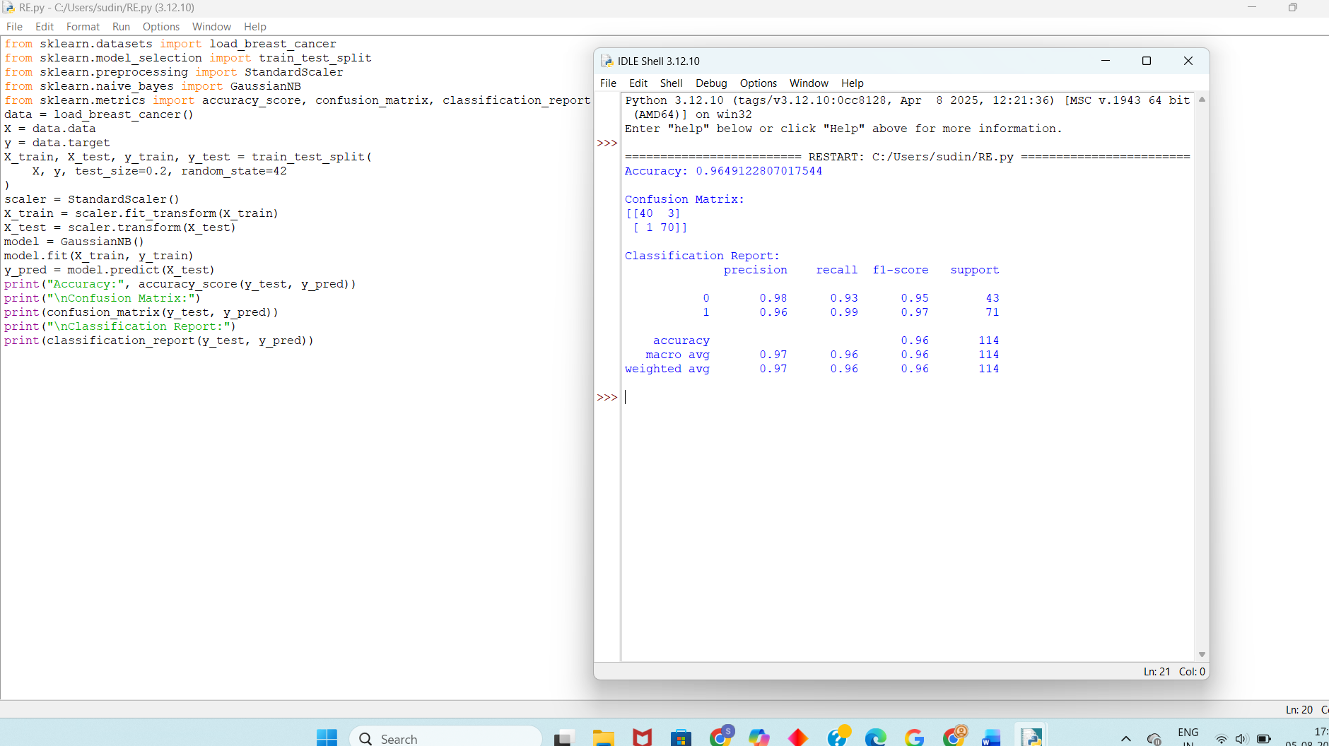
Result:
The Naïve Bayes Algorithm was successfully implemented using Python. The classifier was trained and tested on the Breast Cancer Dataset, and its performance was evaluated using Accuracy, Confusion Matrix, and Classification Report. The model achieved high classification accuracy, demonstrating the effectiveness of the Naïve Bayes algorithm.

